- ZooKeeper is a distributed co-ordination service to manage large set of hosts.
- Co-ordinating and managing a service in a distributed environment is a complicated process. ZooKeeper solves this issue with its simple architecture and API. ZooKeeper allows developers to focus on core application logic without worrying about the distributed nature of the application.
- The ZooKeeper framework was originally built at “Yahoo!” for accessing their applications in an easy and robust manner. Later, Apache ZooKeeper became a standard for organized service used by Hadoop, HBase, and other distributed frameworks. For example, Apache HBase uses ZooKeeper to track the status of distributed data.
- What is distributed application?
  - A distributed application can run on multiple systems in a network at a given time (simultaneously) by coordinating among themselves to complete a particular task in a fast and efficient manner.
  - Normally, complex and time-consuming tasks, which will take hours to complete by a non-distributed application (running in a single system) can be done in minutes by a distributed application by using computing capabilities of all the system involved. The time to complete the task can be further reduced by configuring the distributed application to run on more systems.
  - A group of systems in which a distributed application is running is called a Cluster and each machine running in a cluster is called a Node.
  - A distributed application has two parts, Server and Client application. Server applications are actually distributed and have a common interface so that clients can connect to any server in the cluster and get the same result. Client applications are the tools to interact with a distributed application.
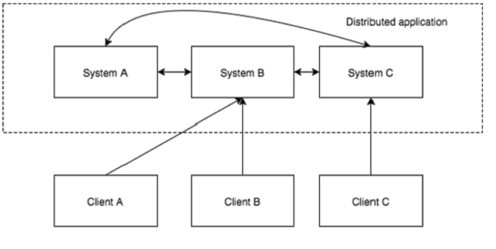
- Benefits of distributed applications
  - Reliability − Failure of a single or a few systems does not make the whole system to fail.
  - Scalability − Performance can be increased as and when needed by adding more machines with minor change in the configuration of the application with no downtime.
  - Transparency − Hides the complexity of the system and shows itself as a single entity / application.
- Challenges of distributed applications
  - Race condition − Two or more machines trying to perform a particular task, which actually needs to be done only by a single machine at any given time. For example, shared resources should only be modified by a single machine at any given time.
  - Deadlock − Two or more operations waiting for each other to complete indefinitely.
  - Inconsistency − Partial failure of data.
- What is Apache Zookeeper meant for?
  - Apache ZooKeeper is a service used by a cluster (group of nodes) to coordinate between themselves and maintain shared data with robust synchronization techniques.
  - ZooKeeper is itself a distributed application providing services for writing a distributed application.
- The common services provided by ZooKeeper are as follows −
  - Naming service − Identifying the nodes in a cluster by name. It is similar to DNS, but for nodes.
  - Configuration management − Latest and up-to-date configuration information of the system for a joining node.
  - Cluster management − Joining / leaving of a node in a cluster and node status at real time.
  - Leader election − Electing a node as leader for coordination purpose.
  - Locking and synchronization service − Locking the data while modifying it. This mechanism helps you in automatic fail recovery while connecting other distributed applications like Apache Hbase.
  - Highly reliable data registry − Availability of data even when one or a few nodes are down.
Distributed applications offer a lot of benefits, but they throw a few complex and hard-to-crack challenges as well. ZooKeeper framework provides a complete mechanism to overcome all the challenges. Race condition and deadlock are handled using fail-safe synchronization approach. Another main drawback is inconsistency of data, which ZooKeeper resolves with atomicity.
- Benefits of Zookeeper
  - Simple distributed coordination process
  - Synchronization − Mutual exclusion and co-operation between server processes. This process helps in Apache HBase for configuration management.
  - Ordered Messages
  - Serialization − Encode the data according to specific rules. Ensure your application runs consistently. This approach can be used in MapReduce to coordinate queue to execute running threads.
  - Reliability
  - Atomicity − Data transfer either succeed or fail completely, but no transaction is partial.
- Architecture of zookeeper
Following diagram depicts the “Client-Server Architecture” of ZooKeeper:
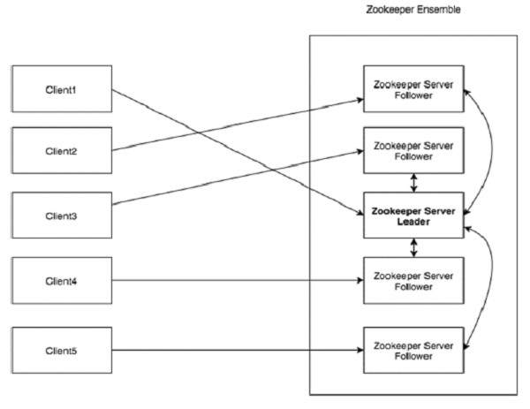

Components of the ZooKeeper architecture:
  - Client: Clients access information from the server. For a particular time interval, every client sends a message to the server to let the sever know that the client is alive.
Similarly, the server sends an acknowledgement when a client connects. If there is no response from the connected server, the client automatically redirects the message to another server.
  - Server: Server, one of the nodes in our ZooKeeper ensemble, provides all the services to clients. Gives acknowledgement to client to inform that the server is alive.
  - Ensemble: Group of ZooKeeper servers. The minimum number of nodes that is required to form an ensemble is 3.
  - Leader: Server node which performs automatic recovery if any of the connected node failed. Leaders are elected on service startup.
  - Follower: Server node which follows leader instruction.
- Hierarchical namespace: The following diagram depicts the tree structure of ZooKeeper file system used for memory representation. ZooKeeper node is referred as znode. Every znode is identified by a name and separated by a sequence of path (/).
  - In the diagram, first you have a root znode separated by “/”. Under root, you have two logical namespaces config and workers.
  - The config namespace is used for centralized configuration management and the workers namespace is used for naming.
  - Under config namespace, each znode can store upto 1MB of data. This is similar to UNIX file system except that the parent znode can store data as well. The main purpose of this structure is to store synchronized data and describe the metadata of the znode. This structure is called as ZooKeeper Data Model.
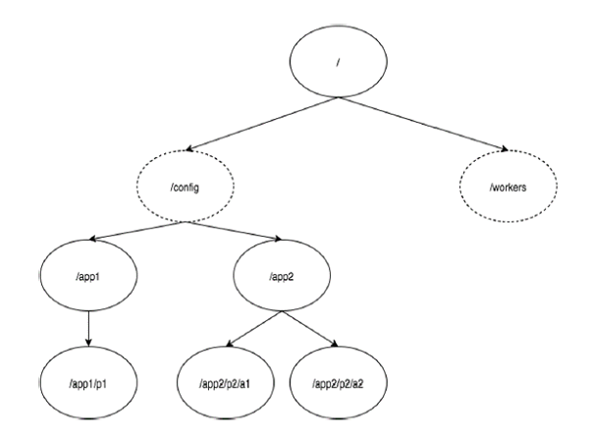

Every znode in the ZooKeeper data model maintains a stat structure. A stat simply provides the metadata of a znode. It consists of Version number, Action control list (ACL), Timestamp, and Data length.
  - Version number − Every znode has a version number, which means every time the data associated with the znode changes, its corresponding version number would also increased. The use of version number is important when multiple zookeeper clients are trying to perform operations over the same znode.
  - Action Control List (ACL) − ACL is basically an authentication mechanism for accessing the znode. It governs all the znode read and write operations.
  - Timestamp − Timestamp represents time elapsed from znode creation and modification. It is usually represented in milliseconds. ZooKeeper identifies every change to the znodes from “Transaction ID” (zxid). Zxid is unique and maintains time for each transaction so that you can easily identify the time elapsed from one request to another request.
  - Data length − Total amount of the data stored in a znode is the data length. You can store a maximum of 1MB of data.
  - Types of Znodes:
    - Persistence znode − Persistence znode is alive even after the client, which created that particular znode, is disconnected. By default, all znodes are persistent unless otherwise specified.
A client can create a znode.
    - Ephemeral znode − Ephemeral znodes are active until the client is alive. When a client gets disconnected from the ZooKeeper ensemble, then the ephemeral znodes get deleted automatically. For this reason, only ephemeral znodes are not allowed to have a children further. If an ephemeral znode is deleted, then the next suitable node will fill its position. Ephemeral znodes play an important role in Leader election.
    - Sequential znode − Sequential znodes can be either persistent or ephemeral. When a new znode is created as a sequential znode, then ZooKeeper sets the path of the znode by attaching a 10 digit sequence number to the original name. For example, if a znode with path /myapp is created as a sequential znode, ZooKeeper will change the path to /myapp0000000001 and set the next sequence number as 0000000002. If two sequential znodes are created concurrently, then ZooKeeper never uses the same number for each znode. Sequential znodes play an important role in Locking and Synchronization.
- Session:
  - Sessions are very important for the operation of ZooKeeper. Requests in a session are executed in FIFO order. Once a client connects to a server, the session will be established and a session id is assigned to the client.
  - The client sends heartbeats at a particular time interval to keep the session valid. If the ZooKeeper ensemble does not receive heartbeats from a client for more than the period (session timeout) specified at the starting of the service, it decides that the client died.
  - When a session ends for any reason, the ephemeral znodes created during that session also get deleted.
- Watches:
  - Watches are a simple mechanism for the client to get notifications about the changes in the ZooKeeper ensemble. Clients can set watches while reading a particular znode. Watches send a notification to the registered client for any of the znode (on which client registers) changes.
  - Znode changes are modification of data associated with the znode or changes in the znode’s children. Watches are triggered only once.
  - If a client wants a notification again, it must be done through another read operation. When a connection session is expired, the client will be disconnected from the server and the associated watches are also removed.
- Zookeeper workflow:
  - Once a ZooKeeper ensemble starts, it will wait for the clients to connect.
  - Clients will connect to one of the nodes in the ZooKeeper ensemble. It may be a leader or a follower node.
  - Once a client is connected, the node assigns a session ID to the particular client and sends an acknowledgement to the client.
  - If the client does not get an acknowledgment, it simply tries to connect another node in the ZooKeeper ensemble.
  - Once connected to a node, the client will send heartbeats to the node in a regular interval to make sure that the connection is not lost.
  - If a client wants to read a particular znode:
    - it sends a read request to the node with the znode path and the node returns the requested data by getting it from its own database. For this reason, reads are fast in ZooKeeper ensemble.
  - If a client wants to store data in the ZooKeeper ensemble:
    - it sends the znode path and the data to the server.
    - The connected server will forward the request to the leader and then the leader will reissue the writing request to all the followers. If only a majority of the nodes respond successfully, then the write request will succeed and a successful return code will be sent to the client. Otherwise, the write request will fail. The strict majority of nodes is called as Quorum.
- Nodes in zookeeper ensemble: Let us analyze the effect of having different number of nodes in the ZooKeeper ensemble.
  - If we have a single node, then the ZooKeeper ensemble fails when that node fails. It contributes to “Single Point of Failure” and it is not recommended in a production environment.
  - If we have two nodes and one node fails, we don’t have majority as well, since one out of two is not a majority.
  - If we have three nodes and one node fails, we have majority and so, it is the minimum requirement. It is mandatory for a ZooKeeper ensemble to have at least three nodes in a live production environment.
  - If we have four nodes and two nodes fail, it fails again and it is similar to having three nodes. The extra node does not serve any purpose and so, it is better to add nodes in odd numbers, e.g., 3, 5, 7.
Zookeeper does most of its operations based on the voting. for example, It marks a write request successful if more than half of the nodes send an acknowledgement. Similarly, it elects a master based on the opinion of more than half of the nodes from the cluster. And finally, it keeps functioning if and only if more than half of the nodes are up. This is basically to server the consistency part of CAP theorem.
We know that a write process is expensive than a read process in ZooKeeper ensemble, since all the nodes need to write the same data in its database. So, it is better to have less number of nodes (3, 5 or 7) than having a large number of nodes for a balanced environment.
The following diagram depicts the ZooKeeper WorkFlow:
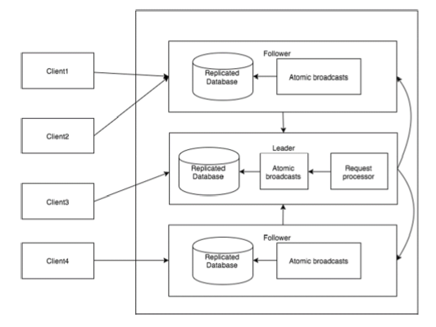
Important points of zookeeper workflow:
Write: Write process is handled by the leader node. The leader forwards the write request to all the znodes and waits for answers from the znodes. If half of the znodes reply, then the write process is complete.
Read: Reads are performed internally by a specific connected znode, so there is no need to interact with the cluster.
Replicated Database: It is used to store data in zookeeper. Each znode has its own database and every znode has the same data at every time with the help of consistency.
Leader: Leader is the Znode that is responsible for processing write requests.
Follower: Followers receive write requests from the clients and forward them to the leader znode.
Request Processor: Present only in leader node. It governs write requests from the follower node.
Atomic broadcasts: Responsible for broadcasting the changes from the leader node to the follower nodes.
- Zookeeper Leader Election: Before getting into leader election, its important to know what happens when a write occurs. Lets assume there are 3 servers, 1 one which is leader and remaining 2 followers. Every write goes through the leader and leader generates a transaction id (zxid) and assigns it to this write request. The id represent the order in which the writes are applied on all replicas.A write is considered succesful if the leader receives the ack from the majority (in this case 1 of the two followers need to ack). This is pretty much the flow for all the writes. The requirement of zxid is that it increases monotonically and is never re-used.
Now lets see what happens when the leader the fails, each follower tries to become leader by broadcasting the last zxid they have seen. Others reply OK if the zxid they have seen is less than or equal and NO if they have a higher zxid. You assume you are the leader if you get OK from the majority and broadcast the same to the followers. This is a simplified version of the leader election. In happy case it looks simple and tempting to implement one. However the challenge is to handle cases like network partitions, race conditions, ties etc.
Most distributed systems uses a variant of bully algorithm to elect leader. The main idea behind the bully algorithm is that any processes or nodes can initiate a election and declare itself as leader. It announces this claim to all other nodes. The other nodes can accept the leader claim. Some nodes reject the claim and they enter into the election process further following the same process. Finally the node that faces no contention is being elected the leader. The attribute for rejection or winning the election could be based on various things like the node/process with highest process/node id (which is the initial bully algorithm or the node that most recent updated transaction history etc.
In Apache zookeeper. The default election algorithm used in zookeeper is Fast Leader Election algoritm and the source is at src/java/main/org/apache/zookeeper/server/quorum/FastLeaderElection.java - zookeeper - Git at Google. The idea behind this algorithm it always it tries to elect the leader as the process that has most uptodate transaction history and it needs to be voted by the majority of the nodes. This mainly has the advantage in that the leader doesn't spend sychronizing with other clients to come to update which pays in terms of time the new leader can become active.
- Zookeeper Installation:
https://www.tutorialspoint.com/zookeeper/zookeeper_installation.htm
- Zookeeper CLI (Command Line Interface): ZooKeeper Command Line Interface (CLI) is used to interact with the ZooKeeper ensemble for development purpose. It is useful for debugging and working around with different options.
To perform ZooKeeper CLI operations, first turn on your ZooKeeper server (“bin/zkServer.sh start”) and then, ZooKeeper client (“bin/zkCli.sh”). Once the client starts, you can perform the following operation −
  - Create znodes (A client can create a znode.)
  - Get data
  - Watch znode for changes
  - Set data
  - Create children of a znode
  - List children of a znode
  - Check Status
  - Remove / Delete a znode
Details of these commands can be found on this link:
https://www.tutorialspoint.com/zookeeper/zookeeper_cli.htm
- Zookeeper API:
  - ZooKeeper has an official API binding for Java and C. The ZooKeeper community provides unofficial API for most of the languages (.NET, python, etc.).
  - Using ZooKeeper API, an application can connect, interact, manipulate data, coordinate, and finally disconnect from a ZooKeeper ensemble.
  - ZooKeeper API has a rich set of features to get all the functionality of the ZooKeeper ensemble in a simple and safe manner.
  - ZooKeeper API provides both synchronous and asynchronous methods.
  - Application interacting with ZooKeeper ensemble is referred as ZooKeeper Client or simply Client.
  - A client should follow the steps given below to have a clear and clean interaction with ZooKeeper ensemble.
    - Connect to the ZooKeeper ensemble. ZooKeeper ensemble assign a Session ID for the client.
    - Send heartbeats to the server periodically. Otherwise, the ZooKeeper ensemble expires the Session ID and the client needs to reconnect.
    - Get / Set the znodes as long as a session ID is active.
    - Disconnect from the ZooKeeper ensemble, once all the tasks are completed. If the client is inactive for a prolonged time, then the ZooKeeper ensemble will automatically disconnect the client.
  - For detailed Java API bindings with the zookeeper, see the following link:
https://www.tutorialspoint.com/zookeeper/zookeeper_api.htm
- Zookeeper provides a flexible coordination infrastructure for distributed environment. ZooKeeper framework supports many of the today's best industrial applications such as apache hadoop, apache hbase, apache solr, etc.
Apache Hadoop:
- Apache Hadoop is the driving force behind the growth of Big Data industry. Hadoop relies on ZooKeeper for configuration management and coordination.
- Let us take a scenario to understand the role of ZooKeeper in Hadoop.
Assume that a Hadoop cluster bridges 100 or more commodity servers. Therefore, there’s a need for coordination and naming services. As computation of large number of nodes are involved, each node needs to synchronize with each other, know where to access services, and know how they should be configured. At this point of time, Hadoop clusters require cross-node services. ZooKeeper provides the facilities for cross-node synchronization and ensures the tasks across Hadoop projects are serialized and synchronized.
- Multiple ZooKeeper servers support large Hadoop clusters. Each client machine communicates with one of the ZooKeeper servers to retrieve and update its synchronization information. Some of the real-time examples are −
Human Genome Project − The Human Genome Project contains terabytes of data. Hadoop MapReduce framework can be used to analyze the dataset and find interesting facts for human development.
Healthcare − Hospitals can store, retrieve, and analyze huge sets of patient medical records, which are normally in terabytes.
Apache Hbase:
  - Apache HBase is an open source, distributed, NoSQL database used for real-time read/write access of large datasets and runs on top of the HDFS (Hadoop Distributed File System).
  - HBase follows master-slave architecture where the HBase Master governs all the slaves. Slaves are referred as Region servers.
  - HBase distributed application installation depends on a running ZooKeeper cluster. Apache HBase uses ZooKeeper to track the status of distributed data throughout the master and region servers with the help of centralized configuration management and distributed mutex mechanisms.
  - Here are some of the use-cases of HBase (Very Very Important)−
Telecom − Telecom industry stores billions of mobile call records (around 30TB / month) and accessing these call records in real time become a huge task. HBase can be used to process all the records in real time, easily and efficiently.
Social network − Similar to telecom industry, sites like Twitter, LinkedIn, and Facebook receive huge volumes of data through the posts created by users. HBase can be used to find recent trends and other interesting facts.
Apache Solr:
  - Apache Solr is a fast, open source search platform written in Java. It is a blazing fast, faulttolerant distributed search engine. Built on top of Lucene, it is a high-performance, full-featured text search engine.
  - Solr extensively uses every feature of ZooKeeper such as Configuration management, Leader election, node management, Locking and syncronization of data.
  - Solr has two distinct parts, indexing and searching. Indexing is a process of storing the data in a proper format so that it can be searched later. Solr uses ZooKeeper for both indexing the data in multiple nodes and searching from multiple nodes.
ZooKeeper contributes the following features −
    - Add / remove nodes as and when needed
    - Replication of data between nodes and subsequently minimizing data loss
    - Sharing of data between multiple nodes and subsequently searching from multiple nodes for faster search results
  - Some of the use-cases of Apache Solr include e-commerce, job search, etc.
- En

